SOC 1; sl I't 131 !N.( .1100.1

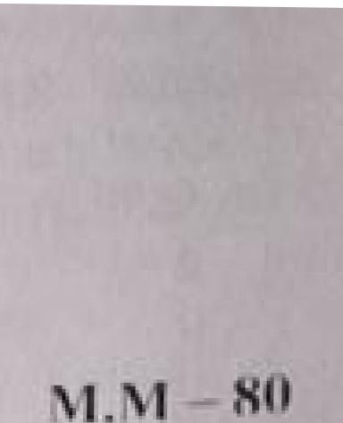

**\ 1 . .411'**

**NN!' JO\ 00211-20**

11.

**51-13.111.:CT—SC1ENCE CLASS —IX**

**'rime: 3 Uri SET-A**

**instructions**

**(0 *The* questiorl paper comprises** fovr St (lion U **Lind D. Then: 36 que.s1 ions iii the q**

**paper. Ali questions arc cornPU1S01-.**

**Cii) Section A Qns_ I to 20 i1 questions kind** [mitts thereof:am or one **mark each. re**

**contain multiple choice questions (NACQ0.. ver.4. short. answer questions** and assertion-

**que-stiors, Alinswers to these should lie E2,11:11 iti one Vet/y(1 or one sentence.**

**(ii) Section 13 Qns... 2 1 to are short ansio..er type questions. curl...in:1 2 imirks** each. Answers to

these **Liucstions !Mould in the ranLI.e of to. 511 words_**

**(iv Section, C. Qns. 27 to 3 3 are Short answer t pc quemtions. carrying** 3 marks each. Arosvocrs **LO**

**thew questions Sholuld in the range or** 50 10 80 1Nords,

(v) Section D Qrts. 3.4 to 36 arc loni4 anslAier type **questions. carrying 5 mark** cach. Answer to 111;:s
  
 **questions should be in the rano.: or** go to vkords.

(v ) ilicre is **no overall choice. I lovi. ever, intcrnal, choices [lave been provided ill some que-st ions.**

**L, has to** attcmpt only one of the **iitturnatives in such titicslitlik'**

(v**ii nceetNary. neat and properly labelled diaurairis should he drawn,**

**Q I. What is the function oft.iolgi appiirolus?**

**Q2, Two objeet...s** or nlascs *m!* **and *lor2* are dropped in vacuum from a height above *the* surface of the c9l-1h *c.ue l* >. *m2).* Which one will reach the grouihd firs'** *and why?*

**Or**

**Happens to the *gravitational* l'orce he leen two objects, i i mass of one oft he ubjecti.i. is hal vo.1%,**

**Q1,3_ Whui is a** mixture. col **sulphur .druff carbon disulphide.** Lotown a_9.1?

**Or**

**Mixture olcorwrion salt and zunmortiunl .011kwide can be separated hy rrieThod?**

**Q4. WhiclunrDinel It: Is iclao n as the suicidal. klav (Ike ecIll?**

4 ).1

**Which of cell organdies have ILti...cred plasma mem hr....ine bouridur2,.?**

**Q5. Write the equation For position- time relation.**

**Pooja took a candle in a vessel arid heated the vessel. 17....eri thougll the candle did not bum. it chart its** shape and state, Whin bind olchange this?

Q7_ Define atomic mass twit

Or

I **itvo do atoms exist**

* **S, The heart does 1,2 *j* of WOO.: i 7 cite Ii heart. heat_ Flow mar,.. time2s per niinute {JINN it *heat* Flom. *t.2r*2 v"1**

**0% What k Ow mass in rani '.{!f5 moles orNa?**

**Q110. 1.1. rip.: the di ire rence be iv.** n tendoi I.and Ii ganionc..

* **I 1, k the uumerical rutin oldis.placontem and LfHanee 1 rao** orkrvinii, ntiject less than.. more ilokno 1.:t4
    
  to II?

Or

A bus increases its speed from 1) to in la s. l i riwl its accelemtion.

012. **VI 11 g0**i**5 tiSed** in joyclr and con[ains 11 o elements gold and palladium. A ..icv.cler Itais tikko

dilTernt samples (hal are **both identical in appe:Irance :Hui Iin L** a miliiron L'omposition **throughout? Whai can It said about the v..1nol.L7s''**

